These are the steps to get MapViewer running. Or at least how I got it to work.

* For this I am using MapViewer 11.1.1.7.3 with Oracle 11g
* For a lot of this crap I had to stumble around to find. Any online tutorials that I found were useless

1. Starting the MapViewer domain should look like this…

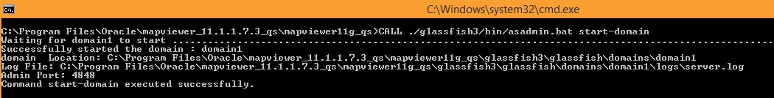

1. Now open MapViewer home and login to the admin area

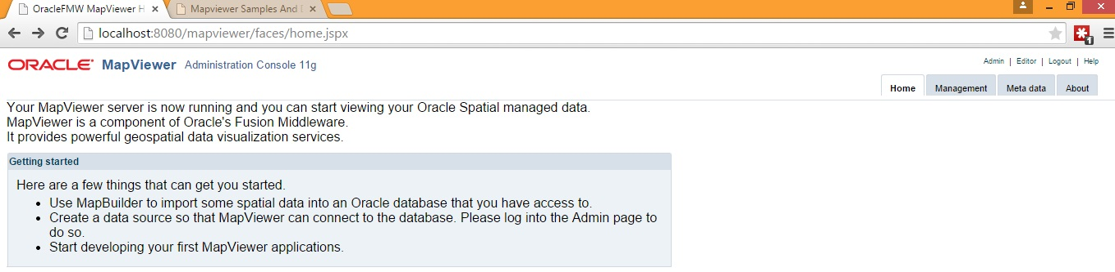

1. In the admin area select “Configuration” from the menu.
2. Scroll down to the “Predefined Data Sources” section
3. I copy-pasted the commented out “mydemo” source that was there and used it as a template to create my “csproj” source  
   Note: password should be prefixed with an exclamation when first entered (ex: !tiger)
4. Click “Save and Restart” at the bottom

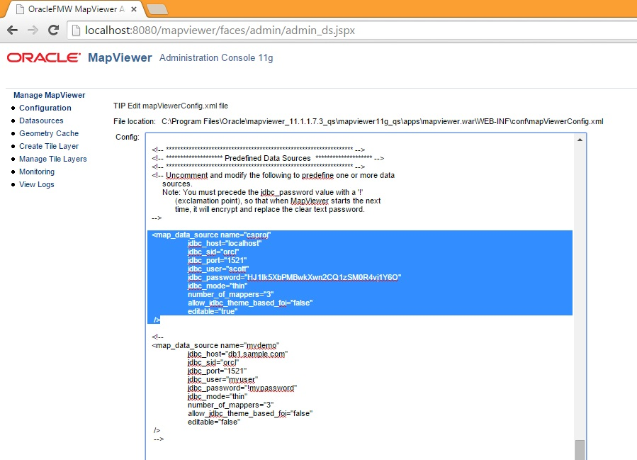

1. Now open the mvdemo page which looks like this…

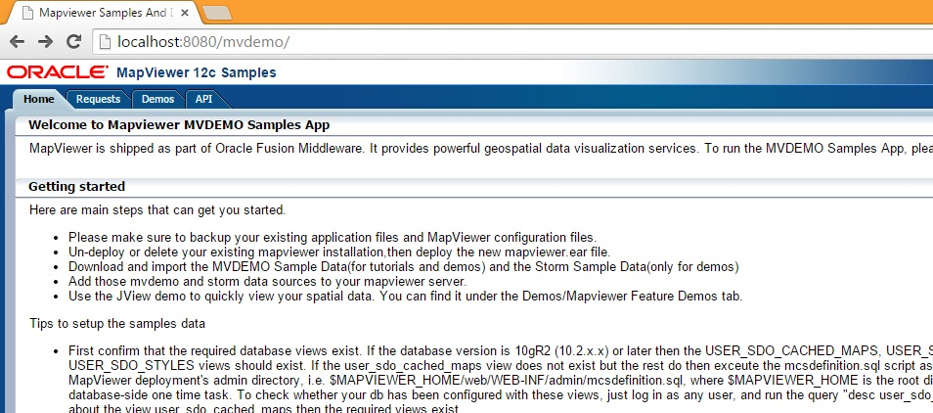

1. Select the “Demos” tab 🡪“MapViewer Feature Demos” 🡪 “JView”

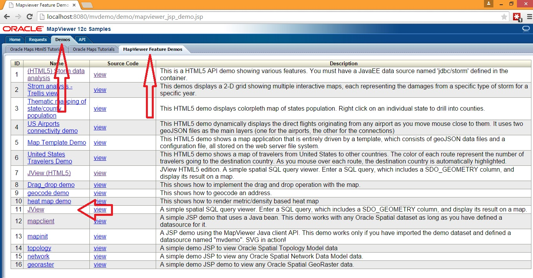

1. If all has gone well you should find yourself here.

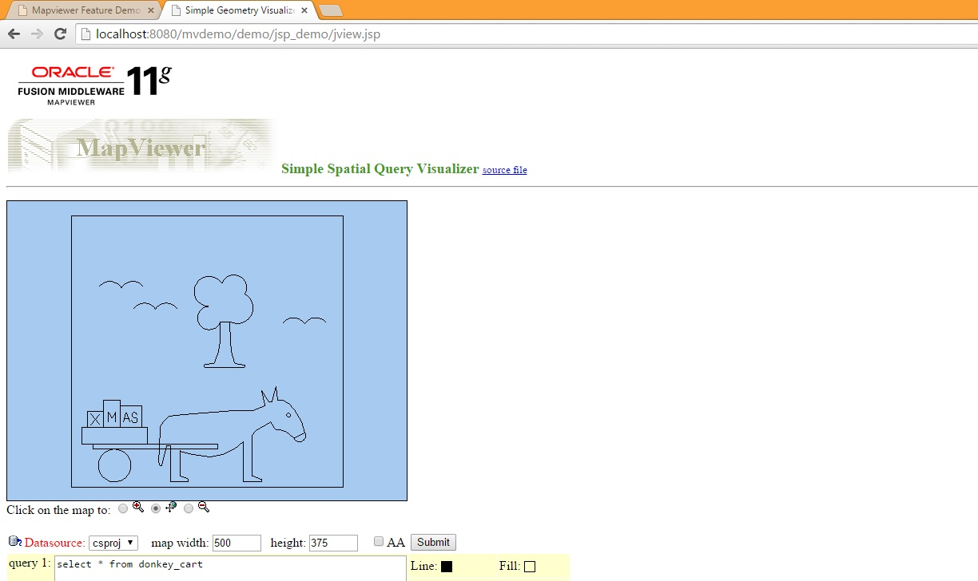

Select your data source from the dropdown, and query your geometry table.